1. . Write a program called CountVowelsDigits, which prompts the user for a String, counts the number of vowels (a, e, i, o, u, A, E, I, O, U) and digits (0-9) contained in the string, and prints the counts and the percentages.

import java.io.*;

public class Main

{

public static void main(String[] args) throws IOException {

BufferedReader br = new BufferedReader(new InputStreamReader(System.in));

String line = br.readLine();

int vowels = 0, digits = 0;

line = line.toLowerCase();

for(int i = 0; i < line.length(); ++i)

{

char ch = line.charAt(i);

if(ch == 'a' || ch == 'e' || ch == 'i'

|| ch == 'o' || ch == 'u') {

vowels++;

}

else if( ch >= '0' && ch <= '9')

{

++digits;

}

}

System.out.println("Vowels: " + vowels);

System.out.println("the percentage of vowels "+ (((float)vowels/(float)line.length())*100));

System.out.println("Digits: " + digits);

System.out.println("the percentage of vowels "+ (((float)digits/(float)line.length())*100));

}

}

Output:

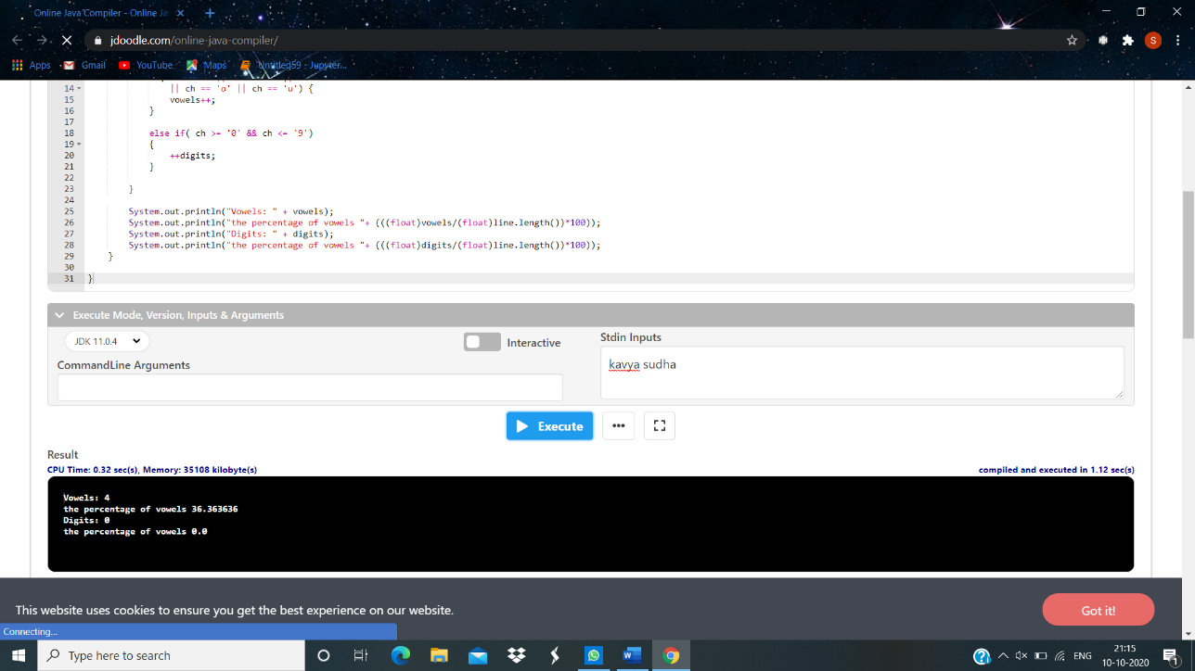

2. Write a program called ReverseString, which prompts user for a String, and prints the reverse of the String by extracting and processing each character.

import java.io.*;

public class MyClass {

public static void main(String args[]) throws IOException {

BufferedReader br=new BufferedReader(new InputStreamReader(System.in));

String s=br.readLine();

MyClass mc=new MyClass();

String r=mc.ReverseString(s);

System.out.println("Given String is : "+s);

System.out.println("Reverse String is : "+r);

}

String ReverseString(String s)

{

String rev="";

for(int i=s.length()-1;i>=0;i--)

rev=rev+s.charAt(i);

return rev;

}

}

Output:

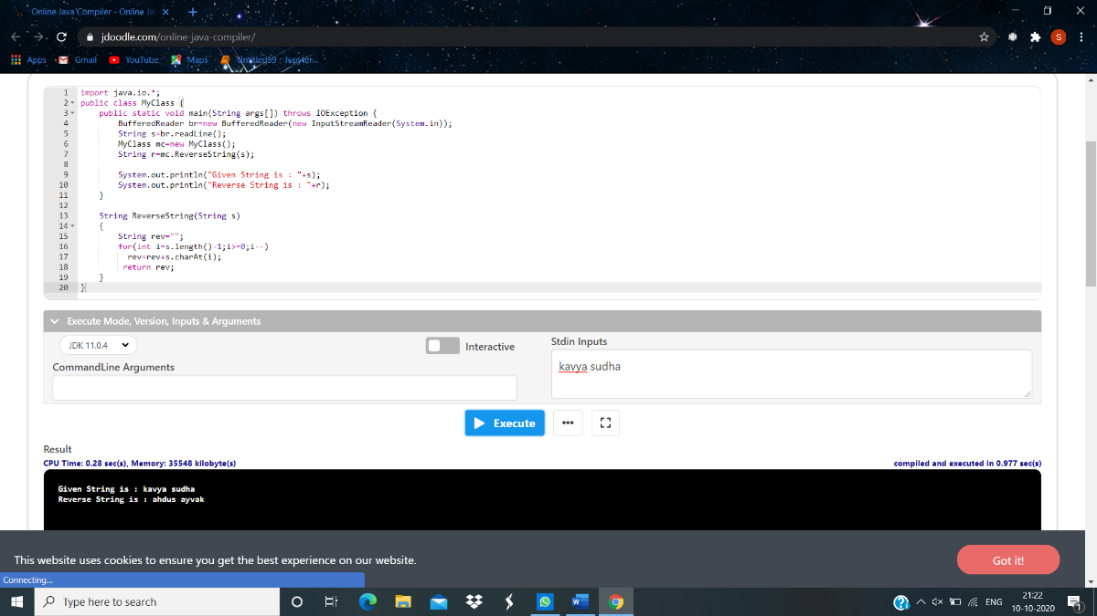

3. Write a Java Program that reads a line of integers, and then displays each integer, and the sum of all the integers.

import java.io.*;

import java.util.*;

public class StringTokenizerDemo {

public static void main(String args[]) {

int n;

int sum = 0;

Scanner sc = new Scanner(System.in);

System.out.println("Enter integers with one space gap:");

String s = sc.nextLine();

StringTokenizer st = new StringTokenizer(s, " ");

while (st.hasMoreTokens()) {

String temp = st.nextToken();

n = Integer.parseInt(temp);

System.out.println(n);

sum = sum + n;

}

System.out.println("sum of the integers is: " + sum);

sc.close();

}

}

Output:

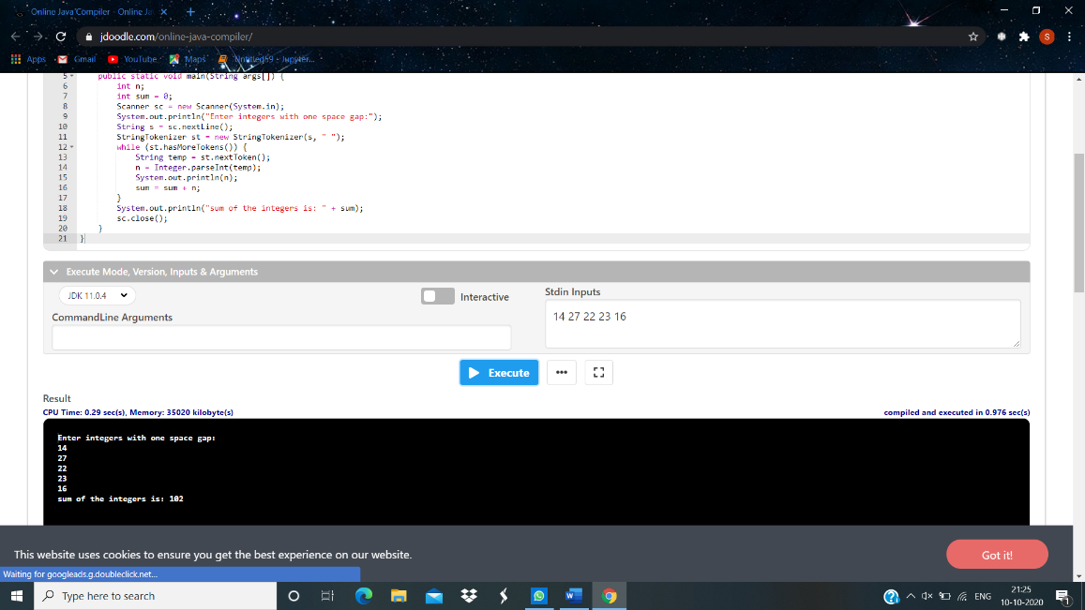

4. Write a Java program to return the sum of the digits present in the given string. If there is no digits the sum return is 0. import java.util.*;

public class Main

{

public int sumOfDigits(String stng)

{

int l = stng.length();

int sum = 0;

for (int i = 0; i < l; i++)

{

if (Character.isDigit(stng.charAt(i)))

{

String tmp = stng.substring(i,i+1);

sum += Integer.parseInt(tmp);

}

}

return sum;

}

public static void main (String[] args)

{

Main m= new Main();

String str1 = "kavya21221";

System.out.println("The given string is: "+str1);

System.out.println("The sum of the digits in the string is: "+m.sumOfDigits(str1));

}

}

Output:

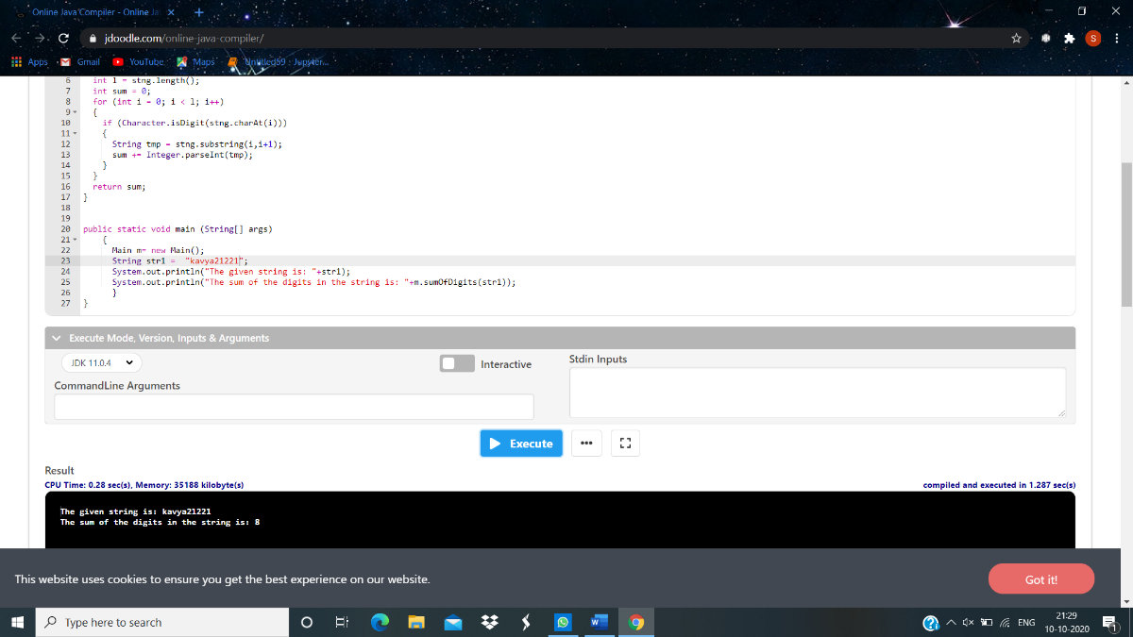

5. Write a Java program to return a new string using every characters of even positions from a given string.

import java.util.*;

public class Main

{

public String makeWithEvenCharacters(String stng)

{

int len = stng.length();

String fin_str = "";

for (int i = 0; i < len; i = i + 2)

{

fin_str += stng.charAt(i);

}

return fin_str;

}

public static void main (String[] args)

{

Main m= new Main();

String str1 = "kavya21221";

System.out.println("The given string is: "+str1);

System.out.println("The new string is: "+m.makeWithEvenCharacters(str1));

}

}

Output:

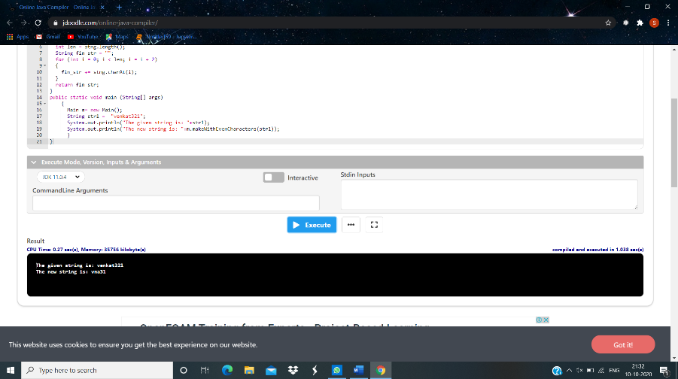

6. Write a Java program to sort a list of names in ascending order.

import java.io.*;

public class Main

{

public static void main(String[] args) throws IOException{

String name[] = new String[5];

String temp="";

int i=0;

BufferedReader br = new BufferedReader(new InputStreamReader(System.in));

for(i=0;i<5;i++){

name[i]=br.readLine();

}

for (i = 0; i < 5; i++)

{

for (int j = i + 1; j < 5; j++)

{

if (name[i].compareTo(name[j])>0)

{

temp = name[i];

name[i] = name[j];

name[j] = temp;

}

}

}

System.out.println("names in alphabetical order");

for(i=0;i<5;i++){

System.out.println(name[i] + " ");

}

}

}

Output:

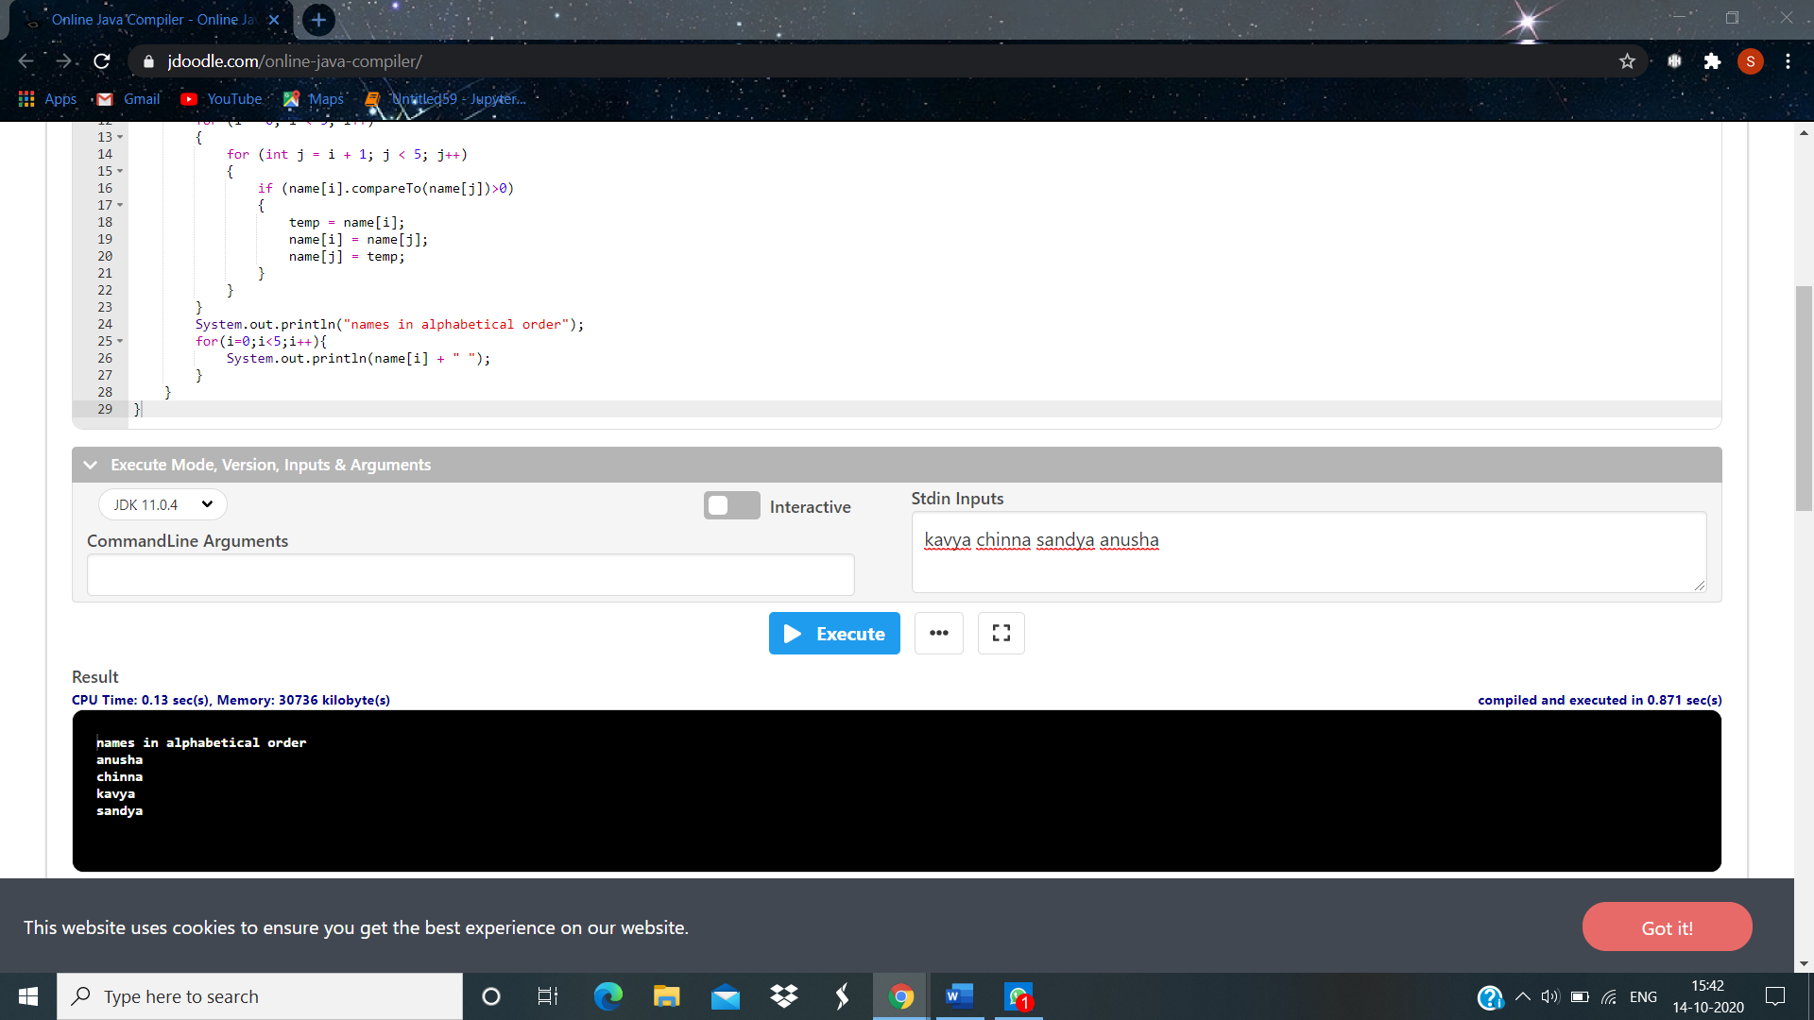

7. Write a Java program to concatenate a given string with itself of a given number of times.

import java.io.*;

public class Main

{

public static void main(String[] args) throws IOException{

String name;

String temp="";

int n;

int i=0;

BufferedReader br = new BufferedReader(new InputStreamReader(System.in));

name=br.readLine();

n = Integer.parseInt(br.readLine());

for(i=0;i<n;i++){

temp+=name;

}

System.out.println("printing name as given no of times " + temp);

}

}

8. Write a Java program to counts occurrences of a certain character in a given string.

import java.io.*;

public class Counting{

public static void main(String[] args) throws IOException{

int count = 0, i;

char ch;

BufferedReader br= new BufferedReader(new InputStreamReader(System.in));

String str = br.readLine();

ch = br.readLine().charAt(0);

for(i = 0; i < str.length(); i++){

if(str.charAt(i) == ch){

count++;

}

}

System.out.println("Total occurences of " + ch + " is "+ count);

}

}

Output:

